**Friday May 10th, 2019 Daily Coding Journal**

11:58 — I’m back. I don’t really know what I need to be doing… but let’s get to it haha.

12:00 — I’m going to review changing state, get that solid, and then move on to the next exercise.

12:08 — Here’s what I put together from scratch thus far. Now I’m going to add an onClick even handler and bind so that I can actually set my state to equal the previous state plus one.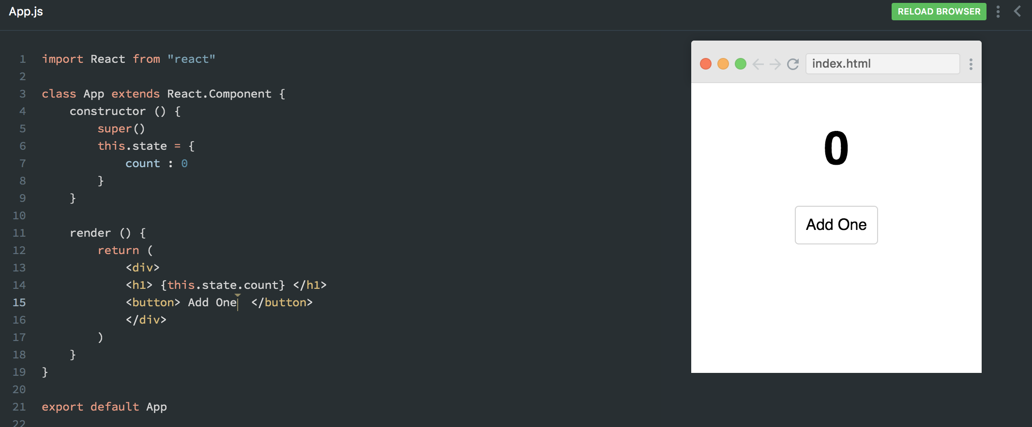

12:23 — I’m very close to being able to build everything from scratch. But… not quite there yet. Here’s what I managed to build on my own:

import React from "react"

class App extends React.Component {

constructor () {

super()

this.state = {

count : 0

}

this.clickHandler = this.clickHandler.bind(this)

}

clickHandler () {

this.setState(prevState => {

count = prevState.count + 1

})}

render () {

return (

<div>

<h1> {this.state.count} </h1>

<button onClick={clickHandler}> Add One </button>

</div>

)

} }

export default App

12:24 — Unfortunately, this code gives me an error:

ReferenceError: clickHandler is not defined (/App.js:58)

12:24 — I’m going to watch this tutorial again and see where I went wrong.

12:26 — One immediate error I noticed when watching the video was that when I used the onClick event handler I passed {clickHandler} instead of {this.clickHandler}

12:32 — Another issue was that inside my clickHandler method I created a function that took in prevState as an argument. No problems there. The issue, however, is I forgot to have my function return anything! O_O

12:34 — What appears to be the final issue is that I tried to set a new value of state using an equal sign instead of a colon.

12:37 — I’m not 100% solid on constructing everything from memory, or even on my own. With that being said, I do feel as if I took a significant step forward in my understanding of changing state during this session. I’m going to get lunch, get some water (I forgot to bring a water this morning), and get rested for the next session!

12:40 — When I come back I’ll give creating everything from scratch another go.

21:08 — I’m back. To be honest, I haven’t been feeling it today. Let’s see if we can try to move the needle just a bit further though.

21:24 — I’ve spent the last 10-15 minutes trying to rebuild everything from scratch again and I’ve gotten close… but I’m having an error where it says setState is undefined. I’m really surprised by this because I have a return inside my setState method and I’ve also used bind to ensure that the setState method was made available via React.Component.

Before I go search the answer, here’s what I produced from scratch in the last 10-15 minutes:

import React from "react"

class App extends React.Component {

constructor(){

super()

this.state = {

count: 0

}

this.clickHandle = this.clickHandle.bind(this)

}

clickHandle () {

return (

setState(prevState => {

count: prevState.count + 1

}))

}

render () {

return (

<div>

<h1> {this.state.count} </h1>

<button onClick={this.clickHandle}> Add one </button>

</div>

)

}

}

export default App

21:28 — It looks like the issue is that I forgot to reference this when setting my state. In other words… my code should’ve looked used the following syntax:

this.setState()

21:32 — The other mistake it looks like I made is that I forgot to return my new count in the form of an object.

21:42 — It turns out my last error was a bit of a bizarre one. It came from having my return statement and what I wanted returned on different lines. Apparently you’re not allowed to do that… I guess?

22:44 — I reviewed everything and I’m exhausted. Man today just isn’t my day. But hey, even on the worst of days, I still got an hour plus in on a day that already had other obligations.

**Total time spent coding today: 1 hour 22 minutes**

**Total time spent coding thus far in May 2019: 20 hours 15 minutes**

**Total lifetime hours of coding: 516 hours 8 minutes**